|  |  |  |  |
| --- | --- | --- | --- |
| Name: | ____________________________________ | | Date: *___________* |
|  | **Year 12 Mathematics: Essentials**  **Investigation 1, 2018**  **Topic - Measurement**  **IN CLASS ONLY** | |  |
| **Total Time:** | 45 mins | / 26  % | |
| **Weighting:** | 7 % |
| **Equipment:** | *Take home component, Scientific calculator* | | |

**DOSAGES**

Children are more sensitive than adults to medications because of their weight, height, physical condition, immature systems, and metabolism.

**Part 1: [6 marks]**

Infant’s and young children’s weight in pounds must be converted to kilograms to accurately calculate medication doses and daily fluid requirements.

***The formula: 2.2 lb = 1 kg***

1. A child weighs 47 lb. Convert the child’s weight to kilograms (round to 2 decimal places)
2. A child weighs 92 lb. Convert the child’s weight to kilograms (round to 2 decimal places)
3. A child weighs 9.5kg. Convert the child’s weight to pounds (round to 2 decimal places)

**Part 2: [12 marks]**

Paediatric patients, which include both infants and children, require special dosing that is adjusted for their body weight. A number of formulas have been used throughout the years to determine the best dose for paediatric patients.

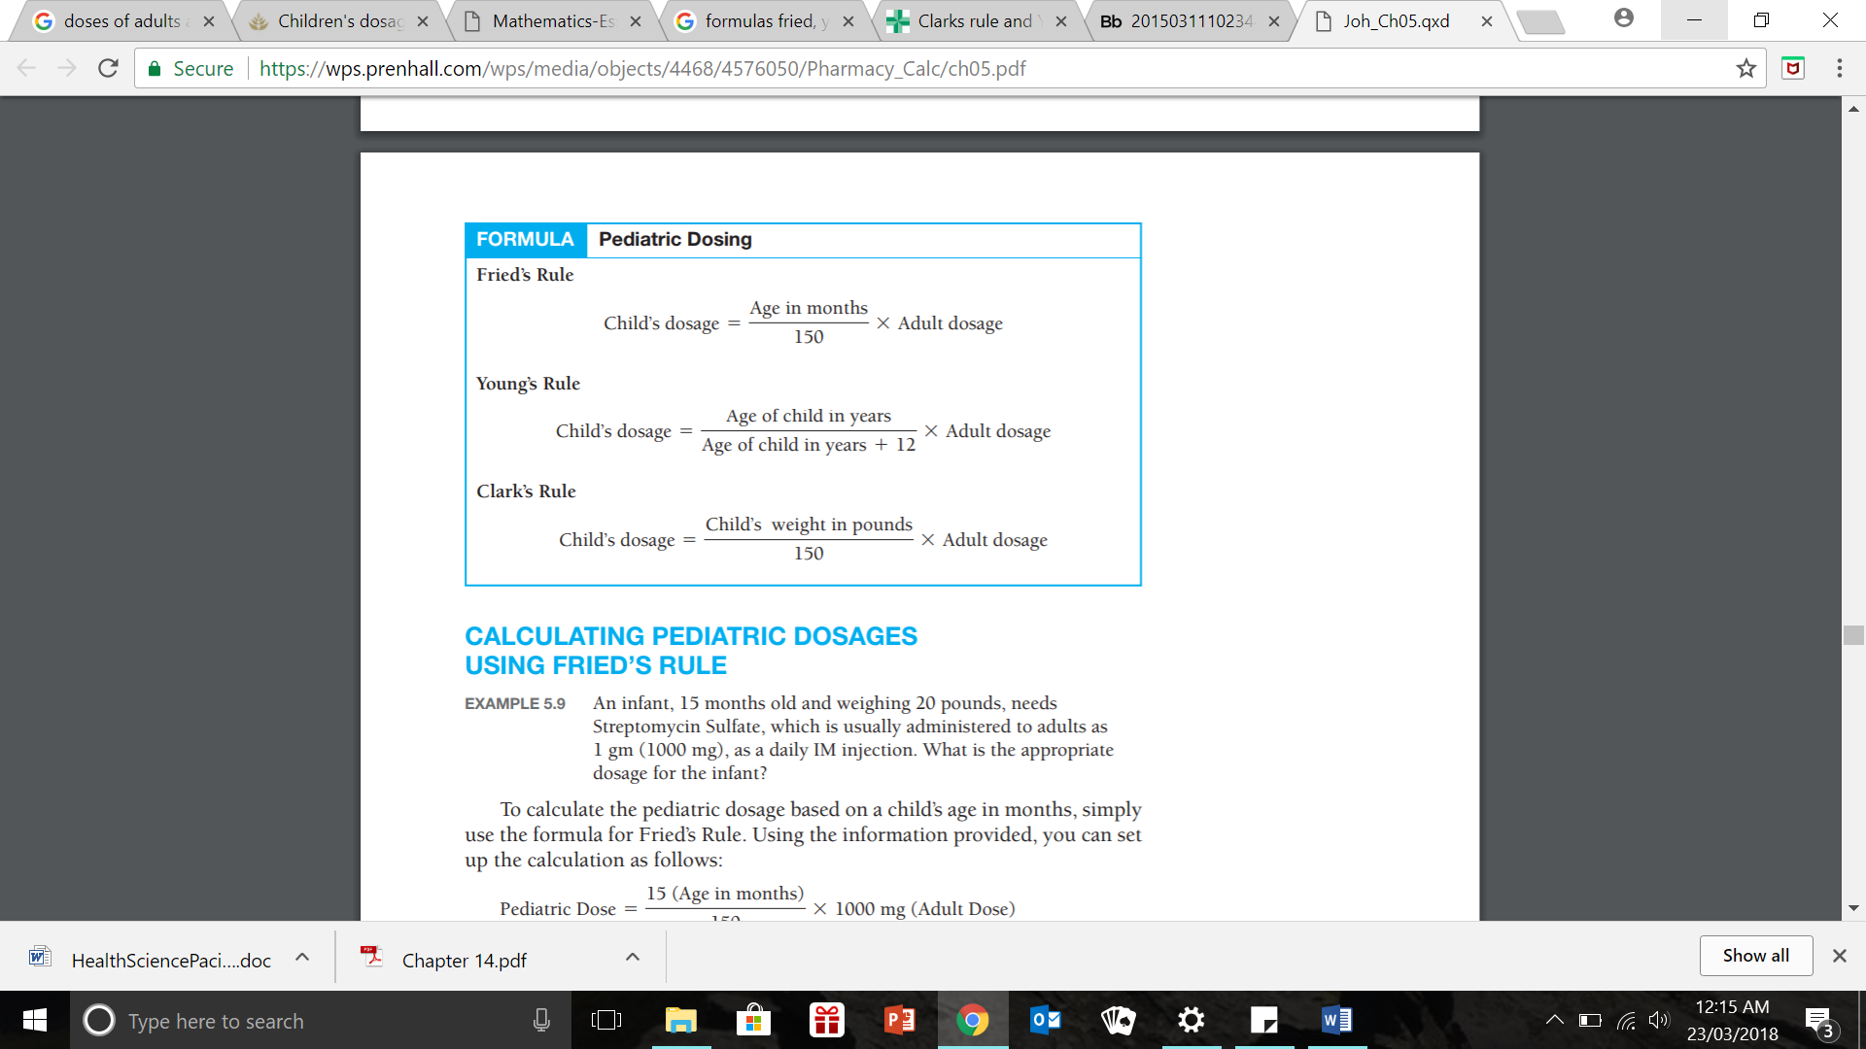

Using **Fried’s** rule:

1. A child, 2 years old, needs acetaminophen, and the normal adult dose is 650 mg. What is the appropriate dosage for the child?
2. An 18-month-old needs amikacin sulfate, and the normal adult dose is 250 mg. What is the appropriate dosage for the child?

Using **Young’s** rule:

1. A 24-month-old child is prescribed amoxicillin, and the normal adult dose is 500 mg. What is the appropriate dosage for the child?
2. A 42-month-old needs propylthiouracil, and the normal adult daily dose is 150 mg. What is the appropriate dosage for the child?

Using **Clark’s** rule:

1. A child, weighing 85 pounds, is prescribed hydrochlorothiazide, and the normal adult dose is 50 mg. What is the appropriate dosage for the child?
2. A child, weighing 70 pounds, is prescribed quinine sulfate, and the normal adult dose is 325 mg TID. What is the appropriate dosage for the child?

**Part 3: [8 marks]**

Calculation of Intravenous (IV) Infusions

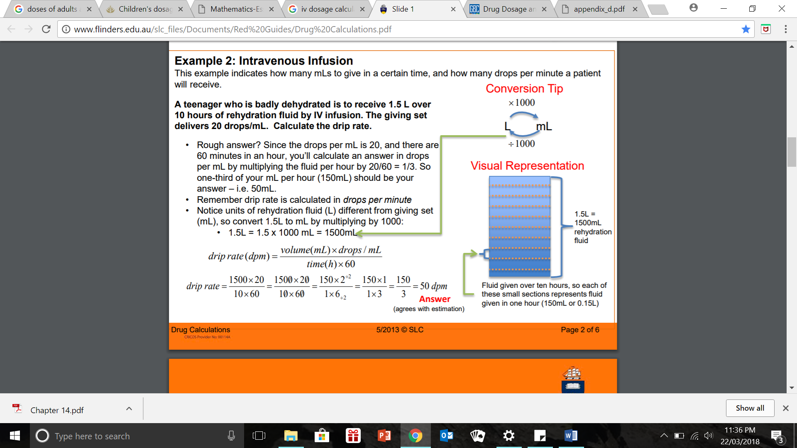***The formula:***

1. Mr Smith is to receive 800mL of an antibiotic via an IV infusion over 15 hours. Calculate the flow rate to be set.
2. 0.5L is to infuse over a 5hour period. Find the flow rate in mL/h.

1. 500 mL of antibiotic is to be infused over the 120 minutes by an infusion pump. Calculate the flow rate (mL per hour).